Parkinsons Disease Prediction

Install the following Libraries
pip install ydata-profiling
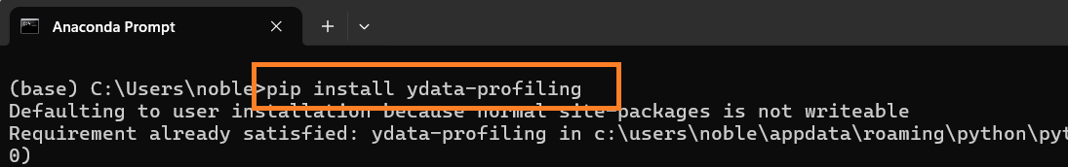

conda install -c conda-forge pandas-profiling
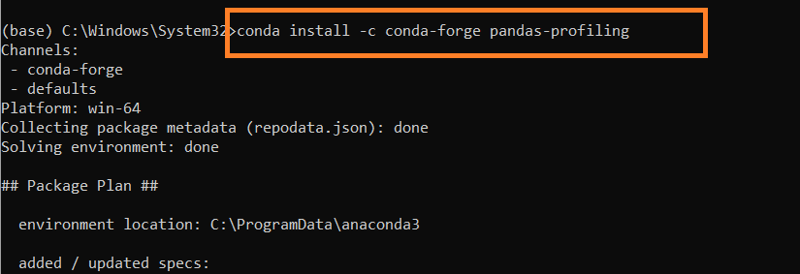

pip install visions

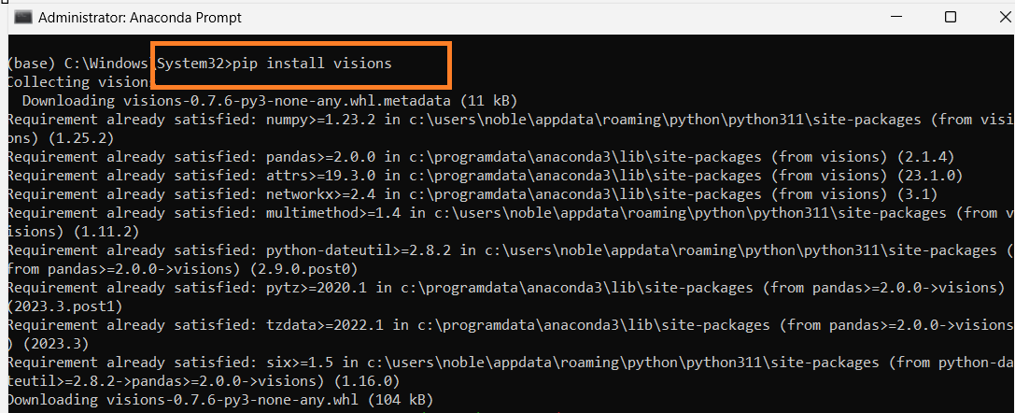

If Profiling is not working and getting an error use the following statement to install pandas profiling

TypeError: concat() got an unexpected keyword argument 'join_axes' | Pandas Profiling

pip install https://github.com/pandas-profiling/pandas-profiling/archive/master.zip

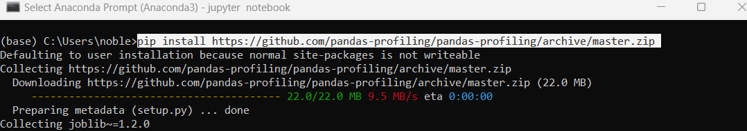

Import Libraries
import pandas as pd
import numpy as np
import seaborn as sns
import matplotlib.pyplot as plt
%matplotlib inline
from sklearn import metrics
from sklearn.model_selection import train_test_split
from sklearn.linear_model import LogisticRegression
from sklearn.ensemble import RandomForestClassifier
from sklearn.metrics import accuracy_score, confusion_matrix, classification_report
import os

Check Current Directory
print (os.getcwd())

Change the directory
os.chdir ('C:\\Noble\\Training\\Acmegrade\\Data Science\\Projects\\Detection of Parkinsons Disease\\')
print (os.getcwd())

Read Data, display records
df=pd.read_csv('parkinsons.data')
display (df)

Attribute Information: Target column - Status

Matrix column entries (attributes):
name - ASCII subject name and recording number
MDVP:Fo(Hz) - Average vocal fundamental frequency
MDVP:Fhi(Hz) - Maximum vocal fundamental frequency
MDVP:Flo(Hz) - Minimum vocal fundamental frequency
MDVP:Jitter(%),MDVP:Jitter(Abs),MDVP:RAP,MDVP:PPQ,Jitter:DDP - Several
measures of variation in fundamental frequency
MDVP:Shimmer,MDVP:Shimmer(dB),Shimmer:APQ3,Shimmer:APQ5,MDVP:APQ,Shimmer:DDA - Several measures of variation in amplitude
NHR,HNR - Two measures of ratio of noise to tonal components in the voice
status - Health status of the subject (one) - Parkinson's, (zero) - healthy
RPDE,D2 - Two nonlinear dynamical complexity measures
DFA - Signal fractal scaling exponent
spread1,spread2,PPE - Three nonlinear measures of fundamental frequency variation

Pandas Profiling Report
import ydata_profiling as pf
display(pf.ProfileReport(df))

Display the shape
display (df.shape)

Number of rows
print (len(df))

Display the data type of all columns
display (df.dtypes )

Display Details
print (df.info())

Describe the details
display (df.describe())

Check for Null Values
display (df.isna().sum() )

Display column details
print (df.columns)
Display the dependent variable
# status - health status of the subject (one) - Parkinson's, (zero) – healthy

print (df['status'])

Create Histogram with Status column
# The dataset has high number of patients effected with Parkinson's disease.
plt.figure(figsize=(10, 6))
df.status.hist()
plt.xlabel('Status')
plt.ylabel('Frequencies')
plt.plot()
plt.show()

Create Bar graph- X-Axis Status, Y- Axis NHR
'''
The patients affected with Parkinson's disease have high NHR which is the measure of the ratio of noise to tonal components in the voice.
'''
plt.figure(figsize=(10, 6))
sns.barplot(x="status",y="NHR",data=df);
plt.show()

Create Bar graph- X-Axis Status, Y- Axis HNR
'''
The patients affected with Parkinson's disease have high HNR
that is the measure of the ratio of noise to tonal components in the voice.
'''
plt.figure(figsize=(10, 6))
sns.barplot(x="status",y="HNR",data=df);
plt.show()

Create Bar graph- X-Axis Status, Y- Axis RPDE
'''
The nonlinear dynamical complexity measure RPDE is high in the patients affected with Parkinson's disease.
'''
plt.figure(figsize=(10, 6))
sns.barplot(x="status",y="RPDE",data=df);
plt.show()

Create Distribution plot – This used to check skewness in data
import warnings
warnings.filterwarnings('ignore')
rows=3
cols=7
fig, ax=plt.subplots(nrows=rows,ncols=cols,figsize=(16,4))
col=df.columns
index=1
for i in range(rows):
for j in range(cols):
sns.distplot(df[col[index]],ax=ax[i][j])
index=index+1

plt.tight_layout()
plt.show()

Display the top 3 records
display (df.head(3))

Display Co relation Matrix
#Excelue the First Column Name
dfc=df.iloc[:,1:]
display (dfc)

# Remove the column status, since it is the dependent variable
dfc = dfc.drop (['status'], axis =1)
corr = dfc.corr()
display (corr)

Display Heat Map
from matplotlib.pylab import rcParams
rcParams['figure.figsize'] = 20,10

sns.heatmap(corr, xticklabels=corr.columns, yticklabels=corr.columns, cmap='cubehelix',annot = True)
plt.show()

Heatmap with Default Parameters
from matplotlib.pylab import rcParams
rcParams['figure.figsize'] = 20,10
sns.heatmap(corr)
plt.show()

Drop the name column
# Removing name column for machine learning algorithms.
df.drop(['name'],axis=1,inplace=True)
display (df)

Spitting the dataset into x and y
Create X
X=df.drop(labels=['status'],axis=1)
display (X.head())

Create – Y
Y=df['status']
display (Y.head())
Splitting the data into x_train, y_train, x_test, y_test

X_train,X_test,Y_train,Y_test=train_test_split(X,Y,test_size=0.2,random_state=40)
print (X.shape,Y.shape)
print(X_train.shape,X_test.shape,Y_train.shape,Y_test.shape)

Create a Logistic Regression Model
log_reg = LogisticRegression().fit(X_train, Y_train)
#predict on train
train_preds = log_reg.predict(X_train)
#accuracy on train
print("Model accuracy on train is: ", accuracy_score(Y_train, train_preds))

#predict on test
test_preds = log_reg.predict(X_test)
#accuracy on test
print("Model accuracy on test is: ", accuracy_score(Y_test, test_preds))
print('-'*50)

#Confusion matrix
print("confusion_matrix train is:\n ", confusion_matrix(Y_train, train_preds))
print("confusion_matrix test is:\n ", confusion_matrix(Y_test, test_preds))
print('\nClassification Report Train is ')
print(classification_report (Y_train, train_preds))
print('\nClassification Report Test is ')
print(classification_report (Y_test, test_preds))

Create Random Forest Model

RF=RandomForestClassifier().fit(X_train,Y_train)
#predict on train
train_preds2 = RF.predict(X_train)
#accuracy on train
print("Model accuracy on train is: ", accuracy_score(Y_train, train_preds2))

#predict on test
test_preds2 = RF.predict(X_test)
#accuracy on test
print("Model accuracy on test is: ", accuracy_score(Y_test, test_preds2))

#Confusion matrix
print("confusion_matrix train is:\n ", confusion_matrix(Y_train, train_preds2))
print("confusion_matrix test is:\n ", confusion_matrix(Y_test, test_preds2))
print('\nClassification Report Train is ')
print(classification_report (Y_train, train_preds2))
print('\nClassification Report Test is ')
print(classification_report (Y_test, test_preds2))

Wrong Predictions made
print((Y_test !=test_preds2).sum(),'/',((Y_test == test_preds2).sum()+(Y_test != test_preds2).sum()))

Kappa Score
print('KappaScore is: ', metrics.cohen_kappa_score(Y_test,test_preds2))

What is the meaning of kappa value?
The higher the kappa value, the stronger the degree of agreement. When:
Kappa = 1, perfect agreement exists. Kappa < 0, agreement is weaker than expected by chance; this rarely happens. Kappa close to 0, the degree of agreement is the same as would be expected by chance

Display the test and Predicted Values
ddf=pd.DataFrame(data=[test_preds2,Y_test])
display (ddf)

Transpose and display

display (ddf.T)

Decision Tree Classifier

from sklearn.tree import DecisionTreeClassifier
#fit the model on train data
DT = DecisionTreeClassifier().fit(X,Y)

#predict on train
train_preds3 = DT.predict(X_train)
#accuracy on train
print("Model accuracy on train is: ", accuracy_score(Y_train, train_preds3))

#predict on test
test_preds3 = DT.predict(X_test)
#accuracy on test
print("Model accuracy on test is: ", accuracy_score(Y_test, test_preds3))
print('-'*50)
#Confusion matrix
print("confusion_matrix train is:\n ", confusion_matrix(Y_train, train_preds3))
print("confusion_matrix test is: \n", confusion_matrix(Y_test, test_preds3))
print('Wrong predictions out of total')
print('-'*50)
print('\nClassification Report Train is ')
print(classification_report (Y_train, train_preds3))
print('\nClassification Report Test is ')
print(classification_report (Y_test, test_preds3))

Wrong Prediction and Kappa Score

# Wrong Predictions made.
print((Y_test !=test_preds3).sum(),'/',((Y_test == test_preds3).sum()+(Y_test != test_preds3).sum()))
print('-'*50)

# Kappa Score
print('KappaScore is: ', metrics.cohen_kappa_score(Y_test,test_preds3))

Naïve Bayce algorithm

from sklearn.naive_bayes import GaussianNB
#fit the model on train data
NB=GaussianNB()
NB.fit(X_train,Y_train)
#predict on train
train_preds4 = NB.predict(X_train)
#accuracy on train
print("Model accuracy on train is: ", accuracy_score(Y_train, train_preds4))

#predict on test
test_preds4 = NB.predict(X_test)
#accuracy on test
print("Model accuracy on test is: ", accuracy_score(Y_test, test_preds4))
print('-'*50)
#Confusion matrix
print("confusion_matrix train is: \n", confusion_matrix(Y_train, train_preds4))
print("confusion_matrix test is:\n ", confusion_matrix(Y_test, test_preds4))
print('Wrong predictions out of total')
print('-'*50)
print('\nClassification Report Train is ')
print(classification_report (Y_train, train_preds4))
print('\nClassification Report Test is ')
print(classification_report (Y_test, test_preds4))

Wrong Prediction and Kappa Score
# Wrong Predictions made.

print((Y_test !=test_preds4).sum(),'/',((Y_test == test_preds4).sum()+(Y_test != test_preds4).sum()))
print('-'*50)

# Kappa Score
print('KappaScore is: ', metrics.cohen_kappa_score(Y_test,test_preds4))
K Neighbours Classifier

from sklearn.neighbors import KNeighborsClassifier
#fit the model on train data
# Using the parameter weights='distance' to fix the error 'Flags' object has no attribute 'c_contiguous'
KNN = KNeighborsClassifier(weights='distance').fit(X_train,Y_train)
#predict on train
train_preds5 = KNN.predict(X_train)
#accuracy on train
print("Model accuracy on train is: ", accuracy_score(Y_train, train_preds5))

#predict on test
test_preds5 = KNN.predict(X_test)
#accuracy on test
print("Model accuracy on test is: ", accuracy_score(Y_test, test_preds5))
print('-'*50)
#Confusion matrix
print("confusion_matrix train is:\n ", confusion_matrix(Y_train, train_preds5))
print("confusion_matrix test is:\n ", confusion_matrix(Y_test, test_preds5))
print('Wrong predictions out of total')
print('-'*50)
print('\nClassification Report Train is ')
print(classification_report (Y_train, train_preds5))
print('\nClassification Report Test is ')
print(classification_report (Y_test, test_preds5))

Wrong Prediction and Kappa Score
# Wrong Predictions made.
print((Y_test !=test_preds5).sum(),'/',((Y_test == test_preds5).sum()+(Y_test != test_preds5).sum()))

print('-'*50)
# Kappa Score
print('KappaScore is: ', metrics.cohen_kappa_score(Y_test,test_preds5))

Support Vector Machine
from sklearn.svm import SVC
#fit the model on train data
SVM = SVC(kernel='linear')
SVM.fit(X_train, Y_train)

#predict on train
train_preds6 = SVM.predict(X_train)
#accuracy on train
print("Model accuracy on train is: ", accuracy_score(Y_train, train_preds6))

#predict on test
test_preds6 = SVM.predict(X_test)
#accuracy on test
print("Model accuracy on test is: ", accuracy_score(Y_test, test_preds6))
print('-'*50)
#Confusion matrix
print("confusion_matrix train is: \n", confusion_matrix(Y_train, train_preds6))
print("confusion_matrix test is:\n ", confusion_matrix(Y_test, test_preds6))
print('Wrong predictions out of total')
print('-'*50)

print("recall", metrics.recall_score(Y_test, test_preds6))
print('-'*50)
print('\nClassification Report Train is ')
print(classification_report (Y_train, train_preds6))
print('\nClassification Report Test is ')
print(classification_report (Y_test, test_preds6))

Wrong Prediction and Kappa Score
# Wrong Predictions made.
print((Y_test !=test_preds6).sum(),'/',((Y_test == test_preds6).sum()+(Y_test != test_preds6).sum()))
print('-'*50)
# Kappa Score
print('KappaScore is: ', metrics.cohen_kappa_score(Y_test,test_preds6))

Create Pickle File
import pickle
# Saving model to disk
pickle.dump(SVM,open('deploy_SVM.pkl','wb'))
# Open the Pickle File
model=pickle.load(open('deploy_SVM.pkl','rb'))
# Prediction
print (model.predict (X_train))

Prediction with Pickle File
Import Libraries
import pandas as pd
import numpy as np
import os
import pickle
from sklearn.metrics import accuracy_score, confusion_matrix, classification_report

Change Working Directory

os.chdir ('C:\\Noble\\Training\\Acmegrade\\Data Science\\Projects\\Detection of Parkinsons Disease\\')
print (os.getcwd())

Load Data Set
df=pd.read_csv('parkinsons.data')
display (df)

Create X

X=df.drop(labels=['status','name'],axis=1)
display (X.head())

Create Y
Y=df['status']
display (Y.head())

Load Pickle File and Prediction with Pickle File

model=pickle.load(open('deploy_SVM.pkl','rb'))
# Prediction
prediction = model.predict (X)
print ( 'Accuracy ',accuracy_score (Y, prediction))
print ()
print ( 'Classification Report')
print (classification_report (Y,prediction,zero_division=0))
print ( 'Confusion Matrix')
print (confusion_matrix (Y,prediction))

Display the Result

result = pd.concat ([df['status'],pd.DataFrame (prediction,columns = ['Prediction'])],axis =1)
display (result.head(50))

